Título: Times or Time New Roman

14 Point Bold, Título

Authors: Times o Times New Roman, 11-point text

Affiliations: Times o Times New Roman 9 point text

Key words: key words that define the subject or research topic.

SECTIONS: SECTION HEADINGS SHOULD BE TIMES OR TIMES NEW ROMAN 10 BOLD BOLD CAPITALS

ABSTRACT:

It should be written as a single block

The abstract is separate, specific and concise and should be between 250 – 300 words.

- INTRODUCTION:
- MATERIALS / METHODS:
- CONCLUSION:
- BIBLIOGRAPHY:

Clancey, William J., 1997 Situated Cognition: On Human Knowledge and Computer representations. Cambridge University press. The Edinburgh Building, Cambridge CB2 2RU, United Kingdom. ISBN 05214449004, pp 406.

Guarino N., Semantic Matching: Formal Ontological Distinctions for Information Organization Extraction and Integration. In M.T. Pazienza (ed.). Information Extraction: A Multidisciplinary Approach to an Emerging Information Technology. Springer Verslag: 139-170, 1998.

Sub-section: Times or Times New Roman 10 point bold.

Main body: Times or Times New Roman, 10 points plain text, single space. A single black line should separate paragraphs.

GENERAL OBSERVATIONS:

The papers maximum extension is 8 pages including tables and images.

Do not include any headers, footers or page numbers. These will be inserted during the production process of the proceedings. Footnotes should be numeric, Times or Times New Roman, 10 point plain text, justified and at the end of the current page (see the example).

FootnotesBibliography should be indicated in the text with the last name of the author and year of publication (e.g. Jansens, 2008). References with more than one author should be indicated in the text with the last name of the author, et al. and the year of publication (e.g. Jansens et al., 2009). References should be listed in alphabetical order and presented as shown in the examples at the end of this document.

Define A4 (21 x 29.7 cm) portrait as page size and then put the following margins:
- Left margin: 4cm
- Right margin: 4cm
- Top margin: 3cm
- Bottom margin: 3cm

Fig. 01 - Figures and tables should be inserted in the text as near as possible to the point from which they are referenced. Figures should not be listed at the end of the paper. Figures and tables may occupy the width of the text area, depending on the size of the figure/table. All figures and tables should be centered horizontally relative to the text.

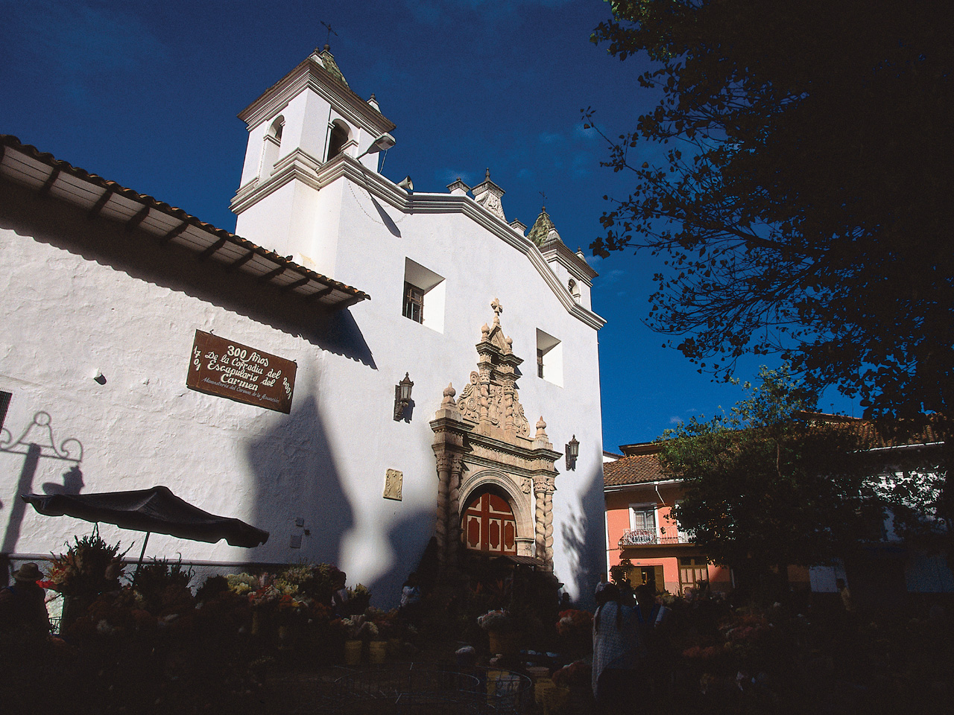
Fig. 01: Title or description of the image.
Author’s Full Name, Title, Page Number(s), Type of Image.

Footnotes: at bottom of each page, Times or Times New Roman, 9 point plain text

